 **Year 8 – Humanities and Social Science**

**Assessment 8 - Direct Action Museum Display**

**Name: _______________________** **Target: ___/44 or ____ % 👍 👎**

|  |  |  |
| --- | --- | --- |
| **Total marks** | **%** | **Weight** |
| **/44** |  | **15%** |

**Date Due: Week 6 Term 2**

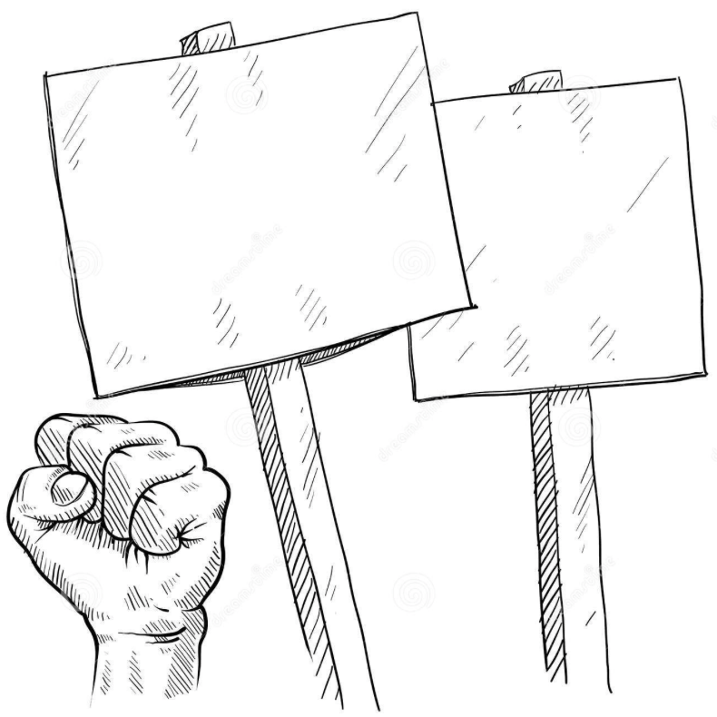**Task:**

You are to create a museum display of democracy in action in Australia. Your exhibition will display a specific example of how citizens have taken direct action such as organising a public demonstration or a social media campaign.

**(PART A): Inquiry Process**

In order to create your museum display you will have to undertake research on a select group or individual who are or have generated change in Australia. Your research must be completed in the attached inquiry booklet.

You must complete:

* A brainstorm on examples of direct action in Australia carried out through public demonstration or social media.
* Focus questions to guide your inquiry
* Note taking sheets
* A bibliography

**(PART B): Museum Display**

Present your findings in a museum display using your inquiry booklet. A majority of the task is to be completed out of class but some in class time may be allocated.

Your display must:

* Include the background of the selected group or individual
* Discuss the issue of the selected group or individual- why were they campaigning?
* List the methods used by your group or individual-social campaigning
* Effectiveness of your selected group/individual in bringing about change
* Discuss how your selected group/individual is in bringing about change
* Discuss how your selected group/individuals public demonstration or social media campaign demonstrates democracy in action.
* Include a visual documentation of your selected group/individuals campaign.
* Be presented in a large box or cabinet or an electronic copy.

**PART A**: Inquiry Booklet

1. **Brainstorm**

Use the box provided below to brainstorm examples of direct action in Australia carried out through a public demonstration or social media campaign.

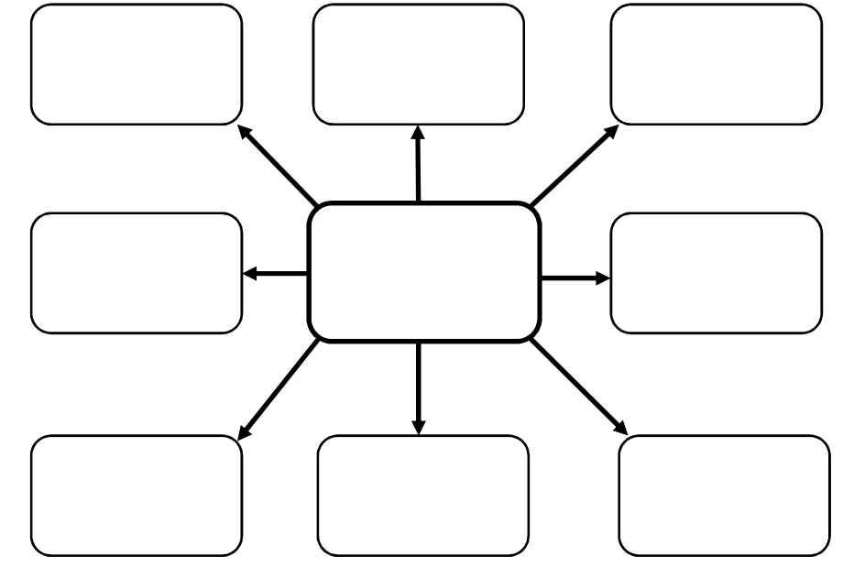

1. **Note taking**

Focus Question 1

|  |
| --- |
|  |

Key points from information sources and reference details

|  |
| --- |
|  |

Focus Question 2

|  |
| --- |
|  |

Key points from information sources and reference details

|  |
| --- |
|  |

Focus Question 3

|  |
| --- |
|  |

Key points from information sources and reference details

|  |
| --- |
|  |

Focus Question 4

|  |
| --- |
|  |

Key points from information sources and reference details

|  |
| --- |
|  |

Focus Question 5

|  |
| --- |
|  |

Key points from information sources and reference details

|  |
| --- |
|  |

Focus Question 6

|  |
| --- |
|  |

Key points from information sources and reference details

|  |
| --- |
|  |

**List of resources used**

**The ethical recording and communicating of evidence:** List the bibliography information of all resources from which you have taken information. You are legally required to acknowledge the author or editor who wrote or compiled the information you have used for your assignment.

**Bibliography/reference list framework**

**Books**

|  |  |  |  |  |
| --- | --- | --- | --- | --- |
| **Author** | **Year** | **Title** | **Publisher** | **Place** |
|  |  |  |  |  |
|  |  |  |  |  |
|  |  |  |  |  |
|  |  |  |  |  |
| **More than one author** |  |  |  |  |
|  |  |  |  |  |

**Encyclopaedia or dictionary**

|  |  |  |  |  |  |  |  |
| --- | --- | --- | --- | --- | --- | --- | --- |
| **Author** | **Year** | **Title of article** | **Title of encyclopaedia** | **Volume** | **Publisher** | **Place** | **Page(s)** |
|  |  |  |  |  |  |  |  |
|  |  |  |  |  |  |  |  |

**Magazine articles**

|  |  |  |  |  |  |  |
| --- | --- | --- | --- | --- | --- | --- |
| **Author** | **Year** | **Title of article** | **Title of magazine** | **Volume** | **Number** | **Page(s)** |
|  |  |  |  |  |  |  |
|  |  |  |  |  |  |  |
|  |  |  |  |  |  |  |

**Newspaper article**

|  |  |  |  |  |  |
| --- | --- | --- | --- | --- | --- |
| **Author** | **Year** | **Title of article** | **Title of newspaper** | **Date** | **Page(s)** |
|  |  |  |  |  |  |
|  |  |  |  |  |  |
|  |  |  |  |  |  |

**Film or video**

|  |  |  |  |  |
| --- | --- | --- | --- | --- |
| **Title** | **Year** | **Format** | **Publisher** | **Place** |
|  |  |  |  |  |
|  |  |  |  |  |

**World wide web – document**

|  |  |  |  |  |
| --- | --- | --- | --- | --- |
| **Author** | **Year or last update** | **Title of website** | **Date retrieved** | **ULR (website address)** |
|  |  |  |  |  |
|  |  |  |  |  |
|  |  |  |  |  |
|  |  |  |  |  |
|  |  |  |  |  |

**World wide web – image**

|  |  |  |  |  |
| --- | --- | --- | --- | --- |
| **Title** | **Format** | **Year** | **Date retrieved** | **ULR (website address)** |
|  |  |  |  |  |
|  |  |  |  |  |
|  |  |  |  |  |

**Online encyclopaedia**

|  |  |  |  |  |
| --- | --- | --- | --- | --- |
| **Title of article** | **Year** | **Title of website** | **Date retrieved** | **ULR (website)** |
|  |  |  |  |  |
|  |  |  |  |  |
|  |  |  |  |  |

**Marking Key**

**PART A: Inquiry Process**

**Name…………………………..……………………………….**

|  |  |  |  |  |  |  |  |  |  |  |
| --- | --- | --- | --- | --- | --- | --- | --- | --- | --- | --- |
| **Description** |  | **Comment** | **1** | **2** | **3** | **4** | **5** | **6** | **7** | **8** |
| 1. **Focus questions.**   Devises a set of questions which clearly identifies the key information needed to address the research question  **6 marks** |  |  |  |  |  |  |  |  |  |  |
| Devises a set of questions which identifies some information needed to address the research question  **4 marks** |  |  |  |  |  |  |  |  |  |  |
| Lists a few simple questions which identify limited information  **2 marks** |  |  |  |  |  |  |  |  |  |  |
|  |  |  |  |  |  |  |  |  |  |  |
| 1. **Selection of information and /or data.**   Selects relevant information and/or data from a number of sources**.**  **8 marks** |  |  |  |  |  |  |  |  |  |  |
| Selects mostly relevant information and/or data from a number of sources  **6 marks** |  |  |  |  |  |  |  |  |  |  |
| Selects some relevant information and/or data from a limited number of sources  **4 marks** |  |  |  |  |  |  |  |  |  |  |
| Selects mostly irrelevant information and/or data from a limited number of sources  **2 marks** |  |  |  |  |  |  |  |  |  |  |
|  |  |  |  |  |  |  |  |  |  |  |
| 1. **Recording of information and /or data.**   Uses appropriate recording techniques to collect and present the information and/or data required by the task  Records sufficient information and/or data  **8 marks** |  |  |  |  |  |  |  |  |  |  |
| Uses mostly appropriate recording techniques to collect and present the information and/or data required by the task  Records sufficient information and/or data  **6 marks** |  |  |  |  |  |  |  |  |  |  |
| Uses simple incomplete recording techniques to collect and present the information and/or data required by the task  Records insufficient information and/or data  **4 marks** |  |  |  |  |  |  |  |  |  |  |
| Uses no logical or organised recording techniques to collect and present the information and/or data required by the task Records insufficient information and/or data  **2 marks** |  |  |  |  |  |  |  |  |  |  |
| **Description** |  | **Comment** | **1** | **2** | **3** | **4** | **5** | 6 | 7 | 8 |
| 1. **Bibliography.**   Presents a bibliography which includes a comprehensive list of sources (e.g. online maps, websites, spatial software applications, print resources and visual media) which correctly follows the referencing technique approved by the school  **2 marks** |  |  |  |  |  |  |  |  |  |  |
| Presents a bibliography which includes a limited list of sources which may follow the referencing technique approved by the school  **1 marks** |  |  |  |  |  |  |  |  |  |  |
| **Total Mark _____/44** | | | | | | | | | | |

**PART B: Museum Display**

|  |  |  |
| --- | --- | --- |
| **Mark:** | **Description:** | **Your Mark:** |
| 20-16 | Explains in detail an example of a public demonstration or social media campaign. Justifies why this is an example of participation through direct action in Australian democracy. Applies relevant terminology and information to suit audience and purpose Includes illustrations which represents in a variety of mediums. |  |
| 11-15 | Provides an explanation of an example of a public demonstration or social media campaign. Explains why this is an example of participation through direct action in Australian democracy. Applies mostly relevant terminology and information to suit audience and purpose. Includes illustrations |  |
| 6-10 | Outlines an example of a public demonstration or social media campaign. Provides some explanation of why this is an example of participation through direct action in Australian democracy. Applies some relevant terminology and concepts to suit audience. Includes illustrations which lack relevant detail. |  |
| 0-5 | Provides a limited outline of a public demonstration or social media campaign. Includes a brief explanation of why this is an example of participation through direct action in Australian democracy. Uses limited terminology. Uses little to no visual materials |  |